**REPORT**

**ESTIMATION OF BUSINESS EXPENSES**

1. **Introduction :** 
   1. **Overview:**

**The report you mentioned focuses on the estimation of business expenses and employs the use of Tableau as a tool to extract insights from the data and present it in the form of visualizations, dashboards, and a narrative (story). This approach enables decision-makers, financial analysts, and stakeholders to gain a deeper understanding of a business's financial health, identify areas for improvement or concern, and make informed decisions to optimize resources and drive growth.**

**1.2 Purpose:**

**The purpose of this approach is to provide a comprehensive and visual representation of a business's expenses, making it easier to analyze and interpret the data. It aims to help businesses:**

**Gain Insights:**

**Visualizing data using Tableau allows for the extraction of meaningful insights from complex datasets, helping businesses understand their spending patterns and areas of potential optimization.**

**Improve Efficiency:**

**By identifying key cost drivers and areas of inefficiency, businesses can make informed decisions to streamline their operations and reduce unnecessary expenses.**

**Enhance Decision-Making:**

**Visualizations and dashboards provide decision-makers with a clear picture of where resources are allocated, enabling more informed decisions on resource allocation, budgeting, and strategic planning.**

1. **PROBLEM DEFINITION & DESIGN THINKING**
   1. **EMPATHY MAP :**

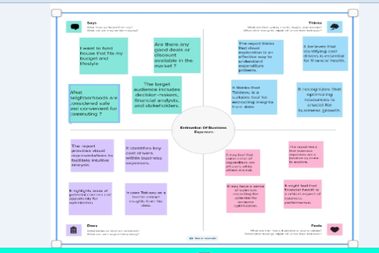

* 1. **BRAIN STORMING :**

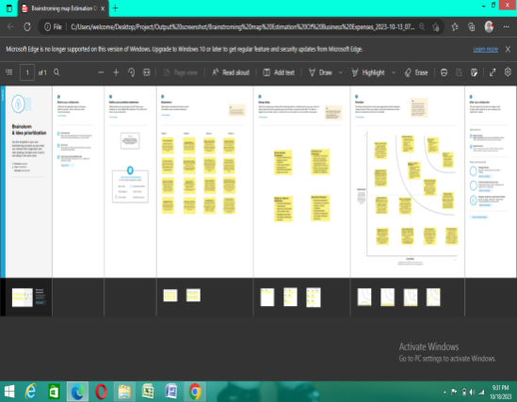

**3.RESULT:**

**3.1 Dashboard :**

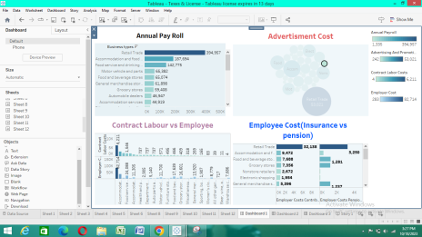 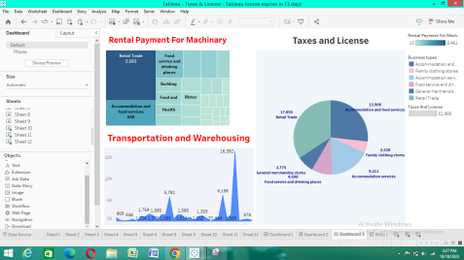

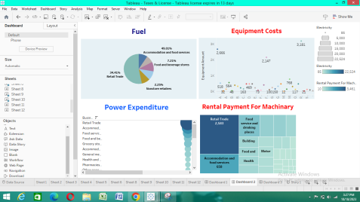

**3.1 Story :**

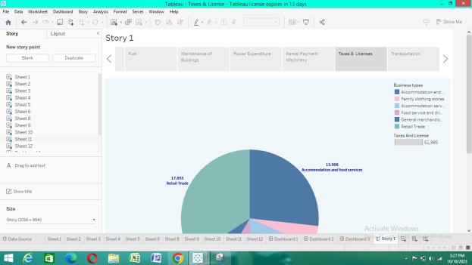

**4. Advantages of Using Tableau for Business Expense Estimation:**

1. **User-Friendly:**

**Tableau is known for its user-friendly interface and ease of use. Users with varying levels of technical expertise can create interactive visualizations and dashboards.**

**2.Powrful Data Visualization:**

**Tableau offers a wide range of visualization options, making it easy to represent complex data in a visually appealing and understandable way. This helps in conveying insights effectively.**

**3.Real-Time Data Connectivity:**

**Tableau allows for the connection to various data sources, including databases, spreadsheets, and cloud services, enabling the visualization of up-to-date data.**

**4.Interactivity:**

**Tableau enables the creation of interactive dashboards where users can explore data, filter information, and gain a deeper understanding of the dataset.**

**5. Storytelling:**

**With Tableau's "Story" feature, you can create a narrative that guides viewers through the data, helping them understand the insights and implications of the data.**

**6. Integration:**

**Tableau can be integrated with various data analytics and business intelligence tools, enhancing its capabilities and potential applications.**

**5. Disadvantages and Considerations:**

1. **Cost:**

**Tableau can be relatively expensive, especially for larger enterprises. Smaller businesses or individuals might find the cost prohibitive.**

1. **Learning Curve:**

**While Tableau is user-friendly, mastering its full potential may require some training and experience.**

1. **Performance:**

**For very large datasets, Tableau's performance may degrade, and complex visualizations might slow down the tool.**

1. **Data Security:**

**When using Tableau with sensitive or confidential data, it's essential to ensure proper data security measures are in place to protect against unauthorized access.**

**In conclusion, using Tableau for business expense estimation and visualization provides numerous advantages, such as user-friendliness, powerful visualization capabilities, and the ability to facilitate data-driven decision-making. However, businesses should carefully consider factors like cost, data security, and performance, and weigh these against the benefits when choosing Tableau as their data visualization tool.**

Applications of Business Expense Estimation with Tableau:

Financial Analysis:

Businesses can use Tableau to analyze their historical expenses, enabling them to identify trends and make informed financial decisions. This can include budgeting, forecasting, and cost reduction strategies.

**Cost Optimization:**

Identifying areas of inefficiency or high expenses through Tableau visualizations can lead to cost optimization. Companies can streamline operations, renegotiate contracts, or eliminate unnecessary expenses.

**Performance Benchmarking:**

Tableau can be used to compare a company's expenses with industry benchmarks, helping businesses understand how they stack up against their peers and make adjustments as needed.

**Resource Allocation:**

Decision-makers can use Tableau dashboards to allocate resources effectively, ensuring that budgetary allocations align with the company's strategic objectives.

**Stakeholder Communication:**

Visual representations in Tableau can be useful for conveying financial information to stakeholders, investors, and shareholders, improving transparency and building trust.

Future Scope:

**Data Integration:**

The future of Tableau lies in enhanced data integration capabilities. As data sources continue to expand and diversify, Tableau is likely to evolve to seamlessly integrate with various data platforms, including cloud-based services and IoT devices.

**Machine Learning and AI:**

Tableau is likely to incorporate more advanced machine learning and AI features, allowing for predictive analytics and automation of insights extraction, making it even more powerful for expense estimation and optimization.

**Mobile and Collaborative Features:**

The future may see improved mobile capabilities and collaboration features, making it easier for teams to access, share, and collaborate on expense data from anywhere.

**Enhanced Security:**

As data privacy and security become increasingly important, Tableau is expected to enhance its security features to protect sensitive financial data.

**Conclusion:**

The use of Tableau for business expense estimation and visualization provides businesses with valuable insights into their financial health, helping them identify areas of inefficiency and opportunity. As the tool continues to evolve, it is poised to play a critical role in financial decision-making and resource optimization.

Tableau's future scope is likely to be driven by advancements in data integration, AI and machine learning, mobile accessibility, and enhanced security. These developments will empower businesses to make even more informed decisions and streamline their operations, ultimately contributing to better financial performance and growth.

In conclusion, Tableau is a valuable tool for businesses looking to gain a deeper understanding of their expenses, and its future advancements will only enhance its capabilities in this regard.